РАЗДЕЛ страница
- Общая информация 3
- Технические характеристики 3
- Общие меры безопасности 3
- Устройства безопасности 3
- Транспортировка 4
- Распаковка 5
- Установка 5

- Место установки 5
- Требования к рабочему месту 5
7. 3 Подсоединение к электросети 6
7.4 Сторона вращения 7
- Предупреждающие сигналы 7
- Опознавание опоры 8

- Рабочее положение 8
- Правильная работа 9
- Использование 10
12. 1 Блокировка колеса 10
12.2 Бескамерные и And Super single Wheels 11
12.2.1 Bead Breaking 11
12.2. 2 Демонтаж 12
12.2.3 Монтаж 14
12. 2. 3. 1 Монтаж шины с диском 14
12. 2.3.2 Монтаж с инструментом, имеющий крючок .... 15
12. 3 Колеса с камерными шинами 17
12. 3. 1 Bead Breaking 17
12.3. 2 Демонтаж 17
12. 3. 3 Монтаж 18
12.4 Колеса с кольцом с прорезью 21
12.4.1 Bead Breaking And Демонтаж 21
12. 4. 1. 1 Колеса с трехсекционным маслосъемным кольцом 21
12.4.1.2 Колеса с 5-сегментными маслосъемными кольцами • • 22
12. 4. 2 Монтаж 23
- Wheels With 3-Piece Split-Rings • • « 23
- Wheels With 5-Segment Split-Rings • • 24

- Текущее обслуживание 25
- Trouble Shooting 26
- Перемещение оборудования 27
- Хранение 27
- Scrapping A Machine 27
- Пневматические схемы 28
- Электрические схемы 29
- Деталировка 30
- Список запчастей 40
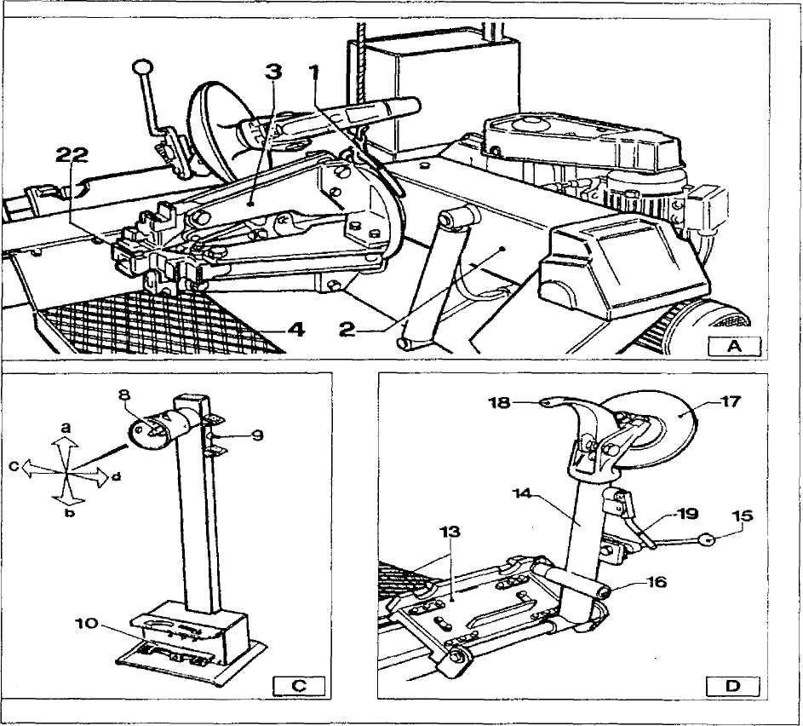

1 | Подъемный кронштейн | 13 | Carriage
2 | Самоцентрирующийся фиксатор прижимного рычага | 14 | Tool holding arm
3 | Самоцентрирующийся фиксатор | 15 | Arm lever
4 | Подвижный стол | 17 | Bead breaking disk
8 | Устройство управления | 18 | Tool
9 | Рубильник | 19 | Tool handle
10 | Педаль | 22 | Jaw

1 Общая информация
Шиномонтажный станок UNITE U-290 был специально спроектирован для демонтажа шин высокоскоростных автобусов и грузовиков с размером обода от 14 дюймов до 26 дюймов и максимальным диаметром 1600мм.
Любое другое использование недопустимо и неавторизованно, перед началом работы с оборудованием внимательно прочтите и примите к сведению всю информацию, содержащуюся в руководстве.
UNITE U-290 shall not liable for any injury to persons or damage to things
caused by improper use of this machine.
Держите руководство рядом с оборудованием и пользуйтесь им во время работы, как только потребуется.
2 Технические характеристики

Двигатель насоса | 1.1КВт
Мотор редуктора | 1.5КВт
Handles rim form | 14-26 дюймов
Максимальный диаметр колеса | 1.600мм
Максимальная ширина колеса | 780мм
Вес (с учетом стандартных аксессуаров) | 518кг
Уровень шума (во время работы) | LPA<70Дб(A)

3 Общие правила безопасности
Пользоваться оборудованием может только специально обученный и квалифицированный персонал. The use of this machine is reserved to specially trained and authorized
personnel.
Любые изменения и модификации конструкции, в частности в электропроводке, оборудования без ведома производителя снимают с него всю ответственность за ремонт оборудования. Any unauthorized changes or modifications to the machine, in particular
to its electrics system, relieve UNITE U-290 form all liability.
Удаление и регулировка устройств безопасности является нарушением установленных европейских норм безопасности. Removing or tampering with the safety devices installed on this machine
is in violation of European safety Regulations.
Любые, даже мельчайшие, работы Any work, however minor, on the electric system must be done exclusively by professionally qualified personnel.

4 Устройства безопасности
Стенд UNITE U-290 снабжен определенным количеством устройств безопасности, которые гарантированы обеспечить безопасность работы оборудования.has a number of safety devices designed to guarantee the utmost operator safety:
- Check valve on the spindle opening hydraulic line(inside the swivel
connector, see fig. B/l). This prevents the wheel form falling form the
spindle if the hydraulic is accidentally broken.
- pilot operated dual seal check valve(see Fig. B/2)
Это предотвратит This prevents the шпиндельный барабан arm from dropping if в случае неожиданнго выхода из строя гидропривода.
3. Pressure relief valve factory set at 130 bar +5%(see Fig. B/3).

This limits the pressure in the hydraulic circuit and ensure correct operation of the plant.
4. pump motor overload cut-out(inside the electric enclosure).
This cuts in if the motor overheats to prevent it from burning out.
5. Mechanical tool arm tip lock device (see Fig. B/4).
Prevents the arm form being moved to its "non-working position" if the tool has been removed.

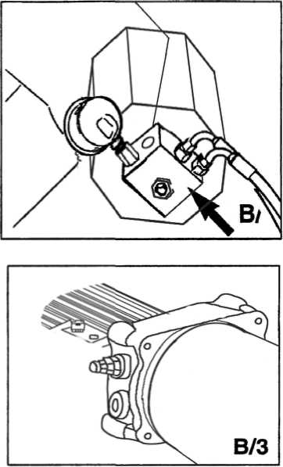
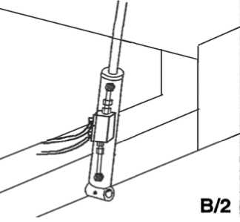
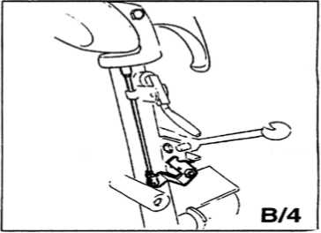
ВНИМАНИЕ!

Removing or tampering with safeties is in violation of European Safety Regulations and relieves manufacturer of any and all liability for injury to persons to damage to things caused or referable to such acts.
5 Транспортировка
В зависимости от выбора клиента, оборудование доставляется в трех видах упаковки:
Виды упаковки:
1- в деревянной связке на паллете
2-фиксировано на паллете
3~без упаковки
При любом виде упаковки оборудование заворачивается в пластиковый чехол.
При первом и втором виде упаковки стенд необходимо грузить с помощью вилочного автопогрузчика, расположение вилок должны быть таким, как указано на рисунке.
При остальных типах упаковки, For the other versions, follow the "MOVING"instructions given on page 32
of this manual.

Транспортировочный вес оборудования 740 кг.

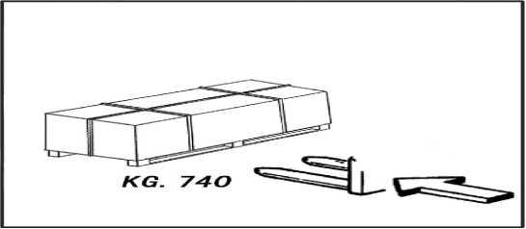

6 Распаковка
После распаковки, проверьте оборудование на наличие каких-либо повреждений.
Храните упаковочный материал вне зоны доступа для детей, так как это может быть угрозой их безопасности.
N. B.: Сохраните упаковку для последующей возможной транспортировки.
7 Установка
7.1 Место установки
Выбирайте место установки оборудования в соответствии с действующими нормами техники безопасности на рабочем месте.
На поверхности пола не должно быть сколов и неровностей, чтобы оборудование находилось в устойчивом положении и колесики платформы могли свободно двигаться.
В том случае, если оборудование предстоит устанавливать на открытой поверхности, необходимо соорудить какое-либо укрытие, чтобы уберечь его от дождя.
Надлежит поддерживать следующие условия окружающей среды: Относительная влажность: 30-95% без конденсации; Температура: 0-55°C.
 ВНИМАНИЕ!
Нельзя работать со станком во взрывоопасной среде.
7. 2 Требования к рабочему месту
Максимальная площадь для установки оборудования 1950х1600, необходимый минимальный промежуток от стены указан на диаграмме.
ОСТОРОЖНО! These measurements are also the tyre changers working range.
Неквалифицированным и неавторизованным работникам строго настрого запрещено заходить за пределы рабочей зоны.
Position the tyre changer lifting it with the specific bracket (1, fig. A)
with the tool carrier arm (2, Fig. A) lowered all the way. the spindle
(3, Fig. A) closed and the tool carrier slide (4, Fig.A) at its stop close
to the arm.

It is not essential to anchor the machine to the floor however, the floor must be smooth and permit the platform rollers to move freely.
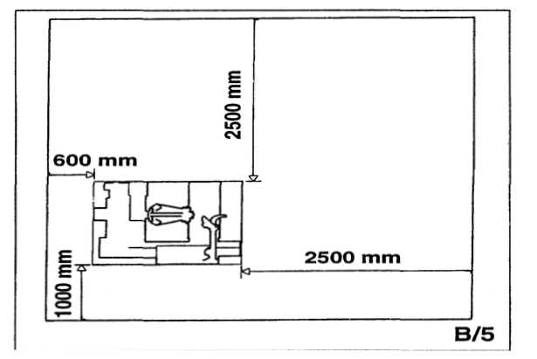
7. 3 ELECTRIC HOOK UP
Before making any electric hook up, check to be certain that the mains
voltage corresponds to that stamped on the voltage tag (attached to the
cord near the tyre changer's plug).
It is absolutely essential that:
-the system is equipped with a good grounding circuit.
-The machine is connected to a power supply line circuit breaker set for
30 mA.
-The current instake is adeguately protected against overcurrents with
fuses or automatic magneto-thermic switch with rated values as swohn in
the table.

power supply | Rated current
power supply | Fuse | Switch
380v-3ph-50/60Hz. | 10A | 16A
Note the required power draw as highlinghted on the data plate fixed to the tyre changer. Check to make sure the shop electric wiring circuit is dimensioned sufficiently to carry this.
Work on the electric system, even if minor, must be done exclusively by professionally qualified personnel.

Manufacturer shall not be liable for any injury to persons or damage to things caused by failure to comply with these regulations and can cancel warranty coverage.

7. 4 SENSE OF ROTATION CHECKS
Connect the machine to the mains, switch "ON"(5, fig. B/7)and check that the gearbox motor rotation corresponds to the indicating arrow(6, fig. B/6).
8 Предупреждающие сигналы

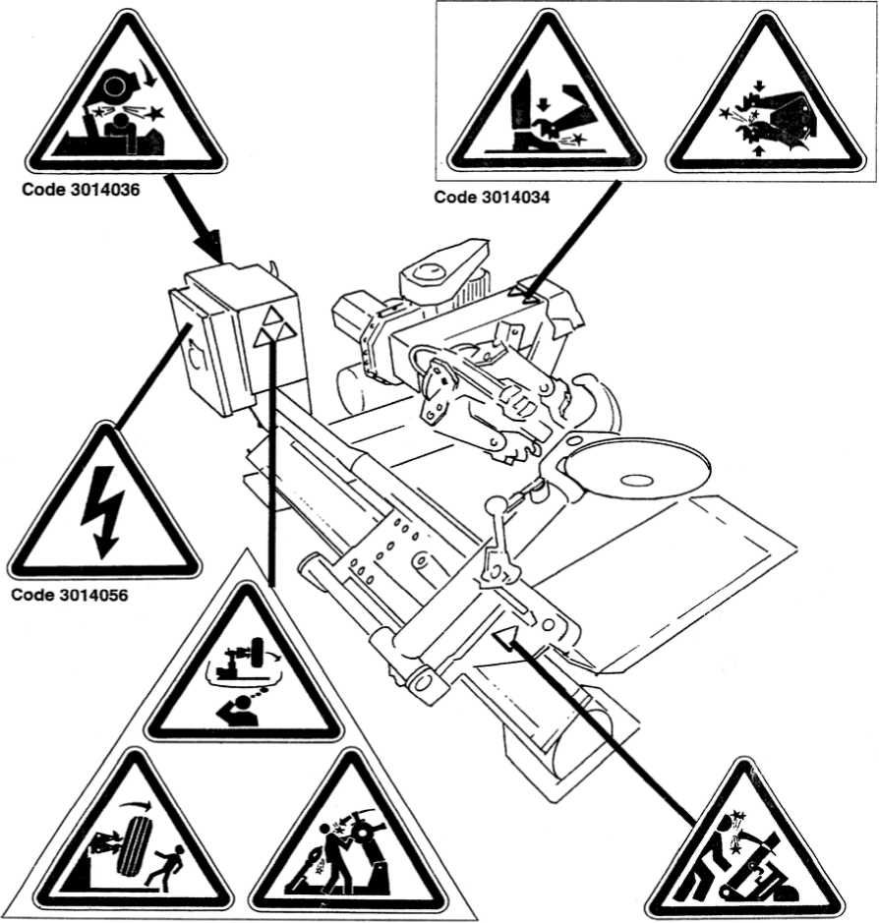

Предупреждение!

Необходимо сразу же восстанавливать утерянные знаки и знаки с неразборчивым изображением.
Следите за тем, что бы не было никаких объектов, которые бы заграждали знаки.Don' t interpose any object witch could prevent the
operator from seeing the labels.
Use the code in this table to order labels that you might
need.

9 IDENTIFICATION OF CONTROL
The mobile control center(fig. c)enables the operator to work at any
position around the machine . on this mobile control center the following
controls are located:
-The lever (8, fig. c)which in position a lifts the chuck arm and in position
b lowers it; in position с moves the tool holder arm and in position d
moves them away. (Note: in order to memorise this operation, there is a hole
in the lever guard corresponding to position c).
-The chuck switch(9, fig. c)when moved upwards, opens the arms of the
self-centering chuck (LOCKING), and when moved down, close the arm of the
self-centering chuck(UN-LOCKING).
-The pedal(10, fig. c)when pressed on the left or right side rotates the
self-centering chuck in the same direction as shown by the arrows placed
on the foot pedal.
NOTE:all the controls are very sensitive and small movements of
the .machine can be done with precision.
The UNITE U-290 tyre changer also has:
Lever(15, Fig. D) to tip the tool carrier arm (14, Fig. 4) form its work to
its non-working position and vice-versa.
Handle(19, Fig. D) that permits alternative use of the bead-breaking
disk(17, Fig. D)or the hooked tool (18, Fig. D).
10 WORKING POSITION
The diagram shown here illustrates the various working positions
(А, В, С, D) referred to in the following pages describing how to use the tyre
changer.

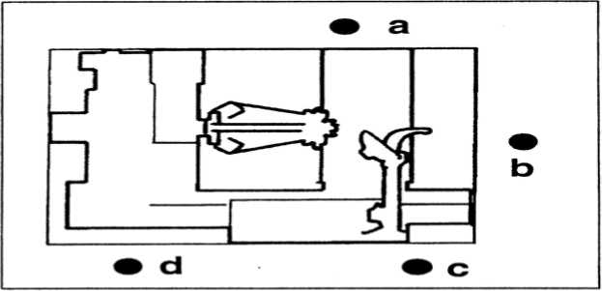
Use of these positions ensures greater precision, speed and safety for those using the machine

Lifting arm lift or lower and hydraulic chuck open or close, there is always a potential for crushing anything in its movement range. Always work form the position given in the instructions keep well out of the working range


11 CORRECT OPERATION CHECKS

Before using the tyre changer, a number of checks should be made to ensure
it works correctly.
CAUTION! The operations described here should be done with the tool
carrier arm in its non-working position.
First use lever(15, Fig. d) to tip the arm to this position.
CAUTION!

Do not move your face close to the tool carrier arm when you
release it to tip it as needed.
1) move the joystick(8, Fig. c)up (a):the spindle carrier arm (2, Fig. a)
should lift ;move the joystick down (b):the arm should lower,
move the joystick towards the left (C):the tool carriage and the mobile
platform(13, Fig. D)should move towards the spindle(3, Fig. A);move the
joystick towards the right (d) the carriage and platform should move away
form the spindle. DANGER!
When the spindle carrier arm is lowered. There is always a potential for crushing anything in its movement range. Always work from the position given in the instructions keep well out of the working range of the various moving arms.

2)Turn switch lever(9, Fig.C) towards the top:the spindle arm should (o Fig A) open; move the lever down and the spindle arms should close.
DANGER!
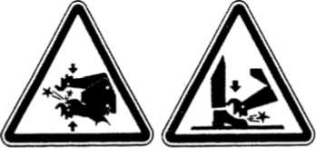
When the spindle arms open or closed, there is always a
potential for crushing anything in their movement
range.
Always work form the position given in the instructions
keep well out of the spindle'swprking range.
3)depress the right pedal(10, Fig. C): the spindle(2, Fig. A) should turn clockwise; depress the left pedal: the spindle should turn anticlockwise. 4)check to be certain the hydraulic circuit is working correctly: -move switch lever(9, Fig. c) towards the top until the spindle arms are fully extended.
-hold the switch lever in this position (Top) and check if the pressure shown on the gauge on the swivel fitting is 130 bar 5%.
If the pressure shown in not as indicated here, do not use the tyre changer and call your nearest Balance assistance center.

12 USE
WARNING!

During all operations, keep hands and the other parts of the body as possible
form moving parts of the machine.
Necklaces, bracelets and too large clothes can be dangerous for the operator.
12.1 LOCKING THE WHEEL

WARNING!
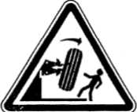
In locking the wheel, make sure that clamps are properly
positioned on the rim, so as to prevent the tyre form falling

- take the mobile control unit to work position B.

- pull the tool-holder arm (14, Fig. D) into the upright
position.

3)Operating form the mobile control center, move the sliding table (13,fig. D) away form the self-centering chuck and place the wheel in vertical position on the sliding table.
4)Continuing to operate form the mobile control center, lift or lower the arm in order center the self-centering chuck(3, fig. a) relative to the rim. 5)With the jaws(22, fig. A) in the closed position, move the wheel on the sliding table to the self-centering chuck. Operate the chuck switch (9, fig. C)to open the self=centering chuck and lock onto the inside wheel rim. The most convenient locking position on the rim may be selected according to figE/1-E/2-E/3-E/4-E/5 and E/6.
Always remember that the safest locking is on the central flange.
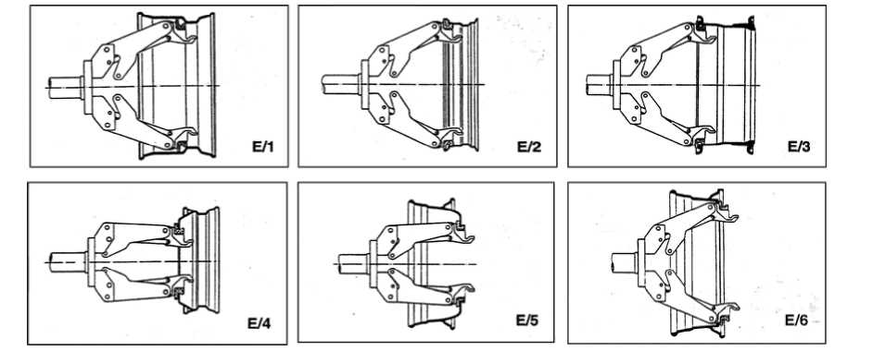
N. B. for rims with channel, clamp the wheel so that the channel is near the outside of the rim (fig. E/1)
10

DANGER!

This operation can be extremely dangerous.
Do it manually only if you are certain you can keep the wheel
balanced.
For large and heavy tyres an adequate lifting device must be used.
DANGER!
Do not very the area with a wheel clamped on the tyre changer
and lifted up from the floor.

12. 2 TUBELESS AND SUPER SINGLE WHEELS
12.2.1 BEAD BREAKING
- Look the wheel on the self-centering chuck, as previously described,
and ensure that the tyre is deflated.
- Take the mobile control unit to work position C.
- LOWER THE TOOL-HOLDER ARM (14, Fig. F) into is working position and allow
it to lock.
- Operating form the mobile centre, manoeuvre the wheel until the outside
of the rim skims the bead-breaker disk(fig. F).
- Rotate the wheel and at the same time, advance the bead-breaker plate
with small forward movements following the profile of the rim, with
the plate.
- Continue until the first bead is fully detached. To facilitate this
operation, lubricate the bead and the edge of rim with tyre lubricant
whilst the wheel is rotated.

DANGER!
Always check to be certain that the arm is corrected hooked to
the carriage.
DANGER!
The bead breaker disk must NOT be pressed against the rim but
against the bead.
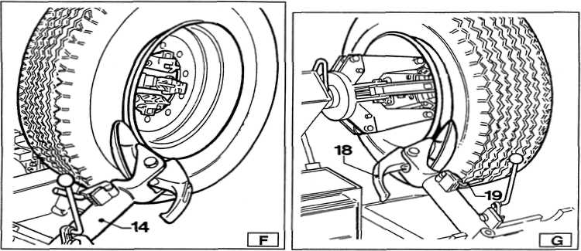
и

CAUTION!

To avoid all risk, lubricate the beads turning the wheel CLOCKWISE if you are working on the outside plane and ANTICLOCKWISE if working on the inside plane.
Remember that the stronger the tyre's adherence to the rim. the slower must be the disk's penetration.
- Bring the tool carrier arm (14, Fig. F) back form the edge of the
rim. Release the hook, raise the arm to its non-working position, shift
it and rehook it in its second work position (Fig. G).
- Push the double headed tool lever (19, Fig. G)and turn the head 180°
until it locks automatically.
Then slide the tool-holder arm along the sliding table and lock it in position.

DANGER!
Do not hold your hands on the tool when you bring it back to its work position. Your hand(s) could be trapped between the tool and the wheel.
Take the mobile control unit to work position D.

9) Repeat the operation previously described until the second bead is completely broken.
N. B. :During the bead breaking. The claw(18, Fig.G) can be lowed so that it is out of the way.
12. 2. 2 DEMOUNTING
Tubeless tyres can be demounted in two ways:
- If the tyre is not difficult to demount, once the beads have been
loosened, use the bead disk to push against the inside plane of the tyre
until both beads come off the rim (see Fig. H)
- With supersingle or very hard tyres the procedure described above
cannot be used. The hook tool will have to be used as follows:
-Transfer the tool carrier arm to the outside plane of the tyre.
Take the mobile control unit to work position С

-Rotate the wheel and at the same time move the hook tool forward inserting it between rim and bead until it is anchored to the bead (see Fig. I) -Move the rim 4-5 cm form the tool taking care that it does not unhook form the bead. -Move the hook tool towards the outside until the red reference dot is
12

by the outside edge of the rim.

Take the mobile control unit to work position B.

-Insert lever BL(17, Fig. I) between rim and bead at the right of the tool.
-Press down on the lever and lower the wheel to bring the edge of the rim
about 5 cm form the hooked tool.
-Turn the wheel anticlockwise pressing down on lever BL until the tool
bead is completely off.
-Move the tool carrier arm to its non-working position and then move it
to the inside plane of the wheel.
Take the mobile control unit to work position D.

-Turn the hook tool 180° and insrt it between rim and bead (see Fig. L). Move it until the bead is by the edge of the rim (best to do this with the wheel turning).
-Move the rim about 4-5 cm from the tool making sure the hook does not detach form the rim.

Take the mobile control unit to work position B.


-Move the hook tool so that its red reference dot is about 3 cm inside the rim.
-Insert lever BL(17, Fig. I) between rim and bead at the right of the tool. -Press down on the lever and lower the wheel to bring the edge of the rim about 5 cm form the hooked tool. Turn the wheel anticlockwise pressing down on lever LA until the tyre comes completely off the rim.
13
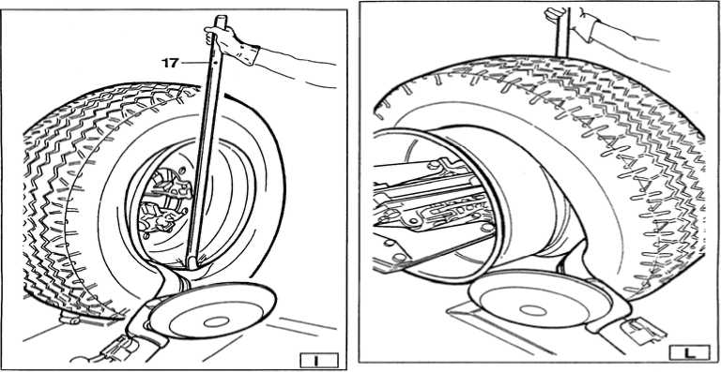

DANGER!
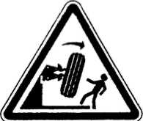
When the beads come off the rim, the tyre will fall. Check to make sure there are no bystanders in the work area.

12.2.3 MOUNTING
Tubeless tyres can be mounted using either the bead breaker disk or the hook tool. If the tyre is not problematic, use the bead loosener disk. If the tyre is very rigid, the hook tool must be used.
12. 2. 3. 1 TYRE MOUNTING WITH THE DISK Follow these steps:
- If the rim has been removed form the spindle, put it back on the spindle
as described in the section on "CLAMPING THE WHEEL"
- Lubricate both beads and the rim with tyre manufacturer recommended
lubricant.
- Attach the RP clip to the outside edge of the rim at the highest
point(see Fig. M).

CAUTION!

Make sure the clip is firmly attached to the rim.
Take the mobile control unit to work position B.
- Put the tyre on the platform and lower the spindle (make sure the clip
is at the high point).
- Lift the rim with the tyre hook to it and turn it anticlockwise about
15-20 cm. The tyre will be positioned tilted across the rim.
Take the mobile control unit to work position C.

- Position the bead loosener disk against the second bead of the tyre
and turn the spindle until the clip is at the low point(at 6 o'clock)
- Move the disk away form the wheel.
- Remove the clip and replace it at 6 o'clock outside the second bead (see
Fig.N).
9) Turn the spindle clockwise 90° to bring the clip to 9 o' clock.
10)Move the disk forward until it is about 1-2 cm inside the edge of the
rim. Begin to turn the spindle clockwise checking to make sure that,
with a 90° turn, the second bead begins to slip into the center well.
ll)When the bead is fully mounted, move the tool away form the wheel,
14

tip it to its non-working position and remove the clip. 12)Position the platform under the wheel, lower the spindle until the wheel rests on the platform.
Take the mobile control unit to work position B.

13) Close the arms of the spindle completely. Support the wheel to prevent it falling off.
DANGER!

This operation can be extremely dangerous. Do it manually only
if you are certain you can keep the wheel balanced.
For large and heavy tyre an adequate lifting device must be used.
14)Move the platform to remove the wheel form the spindle. 15)Remove the wheel.
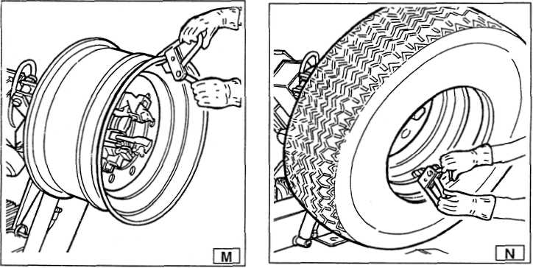
NB:If the tyre permits it, the operation described above can be speeded
up by mounting both beads at the same time:
-Follow the steps described under points 1, 2, 3, 4 described above but
instead attaching the clip to just the first bead (refer to point 4)clip
it to both.
-Lift the rim with the tyre hooked to it and turn it anticlockwise 15-20
cm (clip at 10 o'clock).
-Follow the steps described in points 10, 11, 12, 13, 14, 15 above.
12. 2. 3. 2 MOUNTING WITH THE HOOKED TOOL
- Follow the steps described in points 1, 2, 3, 4, 5 for mounting with the
disk.
- Move the tool carrier arm to its non-working position. Move it to the
inside plane of the tyre and rehook it at this position.
- Check to make sure the hook tool is positioned on the wheel side. If
not, press lever (19, Fig. D)and turn it 180°.
15
Take the mobile control unit to work position D.

4) Move the tool forward until the red reference dot is lined up with the outside edge of the rim and about 5 mm form it(see Fig. 0).

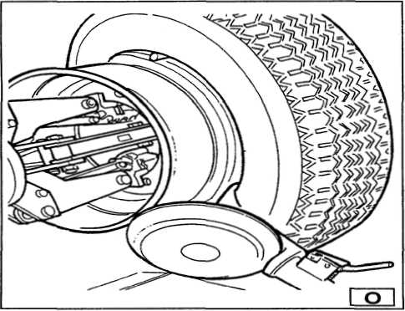
Take the mobile control unit to work position С



- Move to the outside of the wheel and check the exact position of the
took visually and adjust it as needed. Then turn the spindle clockwise
until the clip is at the bottom (6 o'clock). The first bead will be
on the rim.
- Remove the clip.

Take the mobile control unit to work position D.


- Remove the tool from the tyre.
- Move the tool carrier arm to its non-working position. Move it to the
outside plane of the tyre and rehook it in this position.
- Turn the tool 180° with lever(19, Fig. D).
10) Attach the clip at the bottom (6, o'clock) outside the second bead (see
Fig. N)
Take the mobile control unit to work position С

ll)Turn the spindle clockwise to about 90°(clip at 9 o' clock).
12)Bring the tool forward until the red reference dot is lined up with the outside edge of the rim and about 5 mm form it. Begin to turn the spindle clockwise and check if, after about 90° of rotation the second bead has started to slip into the center well. Continue turning until the clip is at the bottom (6 o' clock). The second bead will now be
16

mounted on the rim.
13)Follow the steps described in points 11, 12, 13, 14, 15 for mounting with the disk since this will ensure that the wheel is removed correctly form the machine.
12. 3 TUBED WHEELS
12.3.1 BEAD BREAKING
WARNING:Unscrew the bush which fixes the valve when deflating the tyre
so that the valve, coming in the inside of the rim, is not an obstacle
during bead breaking.
Follow all the steps described previously for bead breaking tubeless
tyres.
With tubed tyres, however, stop disk movement as soon as the bead has
loosened to avoid damaging the tube inflation valve.
12.3. 2 DEMOUNTING
Take the mobile control unit to work position С

- Tip the tool carrier arm (14, Fig. D)to its non-working position. Move
it to the outside plane of the wheel and rehook it in this position.
- Rotate the wheel and at the same time move the hook
tool(18, Fig. D)forward inserting it between rim and bead until it is anchored to the tool.
- Move the rim 4-5 cm form the tool taking care that it does not unhook
form the bead.
- Move the hook tool towards the outside until the red reference dot is
by the outside edge of the rim.
Take the mobile control unit to work position B.

- Insert lever BL(see Fig. P) between rim and bead at the right of the tool.
- Press down on the lever and lower the wheel to bring the edge of the
rim about 5 cm from the hooked tool.
- Turn the wheel anticlockwise pressing down on lever BL until the bead
is completely off.
- Move the tool carrier arm to its non-working position. Lower the
spindle until the tyre is pressed down against the platform. As the
platform is moved slightly towards the outside, the tyre will open a
little and thus create enough space to remove the inner tube.
- Remove the inner tube and lift wheel back up.
Take the mobile control unit to work position D.

17
10) Move the tool carrier arm to the inside plane of the tyre, turn the hook tool 180°
and lower the arm to its work position. Insert it between rim and bead and move it until the bead is by the form edge of the rim( best to do this with the wheel turning).
11)Move the rim about 4-5 cm form the tool making sure the hook does not detach from the rim.
Take the mobile control unit to work position B.

- Move the hook tool so that its red reference dot is about 3 cm in side
the rim.
- Insert lever BL between rim and bead at the right of the tool(see
Fig.Q).
- Press down on the lever and lower the wheel to bring the edge of the
rim about 5 cm from the hooked tool. Turn the wheel anticlockwise
pressing down on lever BL until the tyre comes completely off the rim.
DANGER!

When the beads come off the rim, the wheel will fall. Check to
make sure there are no by-standers in the work area.
12.3.3 MOUNING
- If the rim has been removed from the spindle, put it back on the spindle
as described in the section on "CLAMPING THE WHEEL".
- Lubricate both beads and the rim with tyre manufacturer recommended
lubricant.
- Attach the RP clip to the outside edge of the rim at the highest
point(see Fig. R).
CAUTION!

Make sure the clip is firmly attached to the rim.
Take the mobile control unit to work position B.
- Put the tyre on the platform and lower the spindle (make sure the clip
is at the high point) to hook the first bead on the clip.
- Lift the rim with the tyre hook to it and turn it anticlockwise about
15-20 cm. The tyre will be positioned tilted across the rim.
- Move the tool carrier arm to its non-working position. Move it to the
inside plane of the tyre and rehook it in this position.
- Check to make sure the hook tool is positioned on the wheel side. If
not, press lever(19, Fig. D)and turn it 180°.
18
Take the mobile control unit to work position D.

8) Move the tool forward until the red reference dot is lined up with the outside edge of the rim and about 5 mm from it(see Fig. S)

Take the mobile control unit to work position С


9) Move to the outside of the wheel and check the exact position of the hook visually and adjust it as needed. Then turn the spindle clockwise until the clip is at the bottom (6 o' clock). The first bead will be on the rim. Remove the clip.

Take the mobile control unit to work position D.


- Remove the tool from the tyre.
- Move the tool carrier arm to its non-working position. Move it to the
outside plane of the tyre.
- Turn the tool 180° with lever(19, Fig. D)

Take the mobile control unit to work position B.


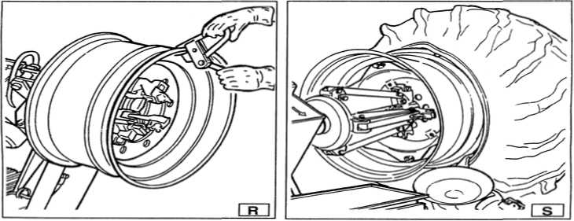
13)Turn the spindle until the valve hole is at the bottom (6 o' clock).
14)Move the platform(4 Fig. A) under the wheel and lower the spindle until the tyre is pressed down against the platform. As the platform is moved slightly towards the outside, the tyre will open a little and thus create enough space to insert the inner tube.
NB:The valve hole may be asymmetrical to the center of the rim. In this
case position and insert the inner tube as shown in Fig . T.
Insert the valve through the hole and fix it with its locking ring.
19

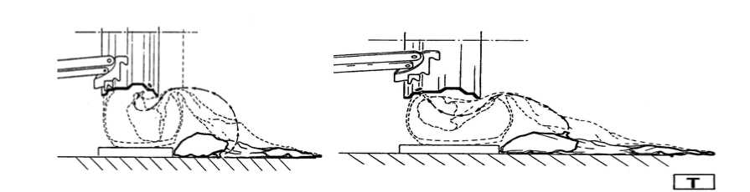
15)Place the inner tube in the center well of the rim(NB:to facilitate

this, turn the spindle clockwise).
16)Turn the spindle until the valve is at the bottom (6 o' clock). 17) Inflate the inner tube a little (until it has no folds) so as not to pinch
it while mounting the second bead.
18)Attach an extension to the valve and then remove the locking ring. NB:The purpose of this operation is to allow the valve to be loose so that it is not ripped out during second bead mounting.

Take the mobile control unit to work position С


19)Move the tool carrier arm (14, Fig. D) to its working position.
20) Bring the tool forward until the red reference dot is lined up with
the outside edge of the rim and about 5 mm from it. 21)Pull back on this lever which will guide the bead into centre well.
Continue to turn the spindle until the tyre is completely mounted on
the rim.
22)Tip the tool carrier arm to its non-working position. 23)Position the platform directly under the wheel and lower the spindle
until the wheel rests on the platform.
- When the wheel is resting on the platform, check to make sure the valve
is perfectly centered with its hole. If it is not, turn the spindle
slightly to adjust the position. Fix the valve with its locking ring
and remove the extension.
- Close the arms of the spindle completely. Support the wheel to prevent
it falling off.
- Move the platform to release the wheel from the spindle.
- Remove the wheel.

DANGER!

This operation can be extremely dangerous.
Do it manually only if you are certain you can keep the wheel
balanced.
For large and heavy tyres an adequate lifting device must be
used.
20

12. 4 WHEELS WITH SPLIT RING
12.4. 1 BEAD BREAKING AND DEMOUNTING 12. 4. 1. 1 WHEELS WITH 3-PIECE RINGS
1) Clamp the wheel on the spindle as described previously and check to make sure it has been deflated.

2)Take the mobile control unit to work position B.


- Lower the tool carrier arm(14, Fig. D) to its work position until it is
locked in position by its hook.
- position the bead loosener disk level with the rim (see Fig. W.)
- Turn the spindle and at the same time move the disk forward a bit at
a time following the contour of the rim until the first bead is completely
free (NB: lubricate while doing this).
CAUTION! If the tyre has an inner tube, work very carefully and be prepared to stop the disk immediately once the bead has been broken so as not to damage the valve and the inner tube.
- Repeat this procedure but this time bring the disk against the
split-ring (see Fig. Z) until the lock ring is freed. Remove this with
the special lever TL(19 Fig. Z) or with the help of the disk.
- Remove the split-ring.
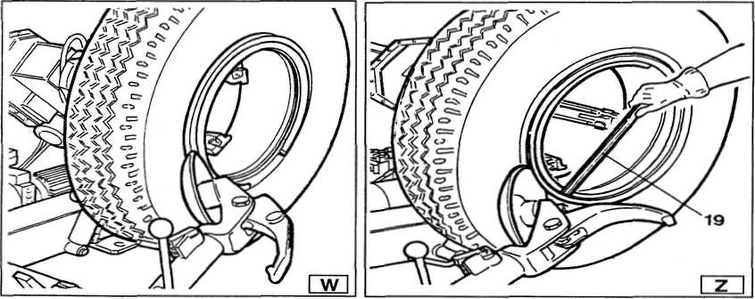
- Move the tool carrier arm (14 Fig. D) back from the edge of the rim.
Release the hook and tip the arm to its non-working position.
Move the tool carrier arm to the inside plane of the wheel.
- Press lever (19 Fig. D) and turn the tool head 180° which will
automatically lock in this position. Lower the arm to its working
position.
10)Turn the spindle and at the same time bring the bead loosener disk up against the tyre following the contour of the split-ring until the second bead has been broken(NB: Lubricate during this process). Continue to move the disk forward until about half the tyre has demounted from the rim(see Fig. K).
21

- Move the tool carrier arm to its non-working position.
- Move the platform(4 Fig. A) directly under the wheel .
- Lower the spindle until the wheel is resting on the platform.

Take the mobile control unit to work position B.

14) Move the platform towards the outside until the tyre completely off the rim. Watch out for the valve!

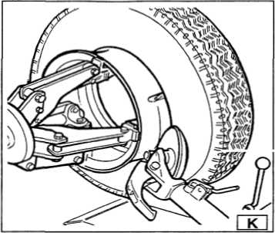
12. 4. 1. 2 WHEELS WITH 5-SEGMENT SPLIT RINGS

1) Clamp the wheel on the spindle as described previously make sure it
is deflated.
Take the mobile control unit to work position С

- Lower the tool carrier arm (14 Fig . D) to its work position until its
hook has clicked into position on the bar.
- Use the joystick to position the wheel so that the bead breaker disk
touches up against outside edge of the centre well rim.
- Turn the spindle and at the same time move the bead breaker disk forward
until the split-ring is detached. Watch out for the o-ring.
- Repeat this operation but this time move the disk against the
split-ring(see Fig. Z) until the locking ring is released. This ring
can be removed with the special TL lever (19, Fig. Z) or with the help
of the bead disk.
- Remove the o-ring.
- Move the tool carrier arm (14, Fig. D) back from the edge of the rim.
Release the hook and tip the arm to its non-working position.
- Press lever (19, Fig. D) and turn the tool head 180° which will
automatically lock in this position. Lower the arm to its working
position.


> \ Take the mobile control unit to work position D.
9) Turn the spindle and at the same time bring the bead loosener disk up
22

against the tyre between the rim and bead. Move the disk into tyre only when the bead has started to detach from the rim and move the bead to the outside edge of the rim. (NB:Lubricate during this process). 10)Tip the tool carrier arm to its non-work position.
Take the mobile control unit to work position B.

11)Move the platform (4, Fig. A) directly under the wheel.
12)Lower the spindle until the wheel is resting on the platform.
13)Move the platform towards the outside until the tyre together with the
split ring comes completely off the rim. 14)Remove the rim from the spindle. 15)Position the tyre on the platform with the splint ring turned towards
the spindle. 16)Clamp the split ring on the spindle as explained in the section of
CLAMPING THE ^{nfTTT?T?T}

DANGER!
The tyre is not attachcrd to the split ring completely safely. Any stain on it during position or clamping operstions could cause to detach and fall.
Take the mobile control unit to work position D.
17) Lift the wheel.
18)Move the tool carrier arm back to its work position.
19)Position the spindle so that the bead breaker disk is lined up with
the bead. 20)Turn the spindle and move the disk fosk forward until the tyre comes
completely off the split ring.

DANGER!
When the beads come off the rim , the wheel will fall. Check to make sure there are no by-standers in the work area.
12.4. 2 MOUNTING
12. 4. 2. 1 WHEEL WITH 3-PIECE SPLIT-RINGS
1) Move the tool carrier arm to its non-working position. If the rim has
been removed from the spindle, put it back on the spindle as described
in the section on "CLAMPING THE WHEEL"
If the tyre is tubed, position the rim with the valve slot at the bottom(6 o' clock).
2) Lubricate both beads and the rim with tyre manufacturer recommended
lubricant
23
Take the mobile control unit to work position B.

3) Move the platform to be able to place the tyre on it.
NB:If the tyre is tubed, position the rim with the valve slot at the bottom(6 o' clock)
- Lower or raise the spindle to centre the rim and the tyre.
- Move the platform forward until the rim is inserted into the tyre.
CAUTION! If the tyre is tubed push the valve inside so as not to damage
it. Move forward with the platform until rim is comoletely in the tyre.
6) Bring the tool carrier arm to the outside plane and lower it to its
work position with the disk towards the wheel.
NB: If the tyre is not inserted sufficiently on the rim, move the spindle unitl the tyre bead is by the disk. Bring the disk forward (with the spindle turning) until it is completely inserted.
- Put the split-ring on the rim and then install the locking ring with
the help of the disk as shown in Fig. Y.
- Move the tool carrier arm to its non-working position and, at the same
time, close the spindle arms. Support the wheel so that it does not
fall off.
DANGER!

This operation can be extremely dangerous.
Do it manually only if you are certain you can keep the wheel
balanced.
For large and heavy tyres an adequate lifting device must be used.
9) Move the platform to free the wheel from the spindle.
10)Remove the wheel.
12. 4. 2. 2 WHEELS WITH 5-SEGMENT SPLIT-RINGS
- Move the tool carrier arm to its non-working position. If the rim has
been removed from the spindle, put it back on the spindle as described
in the section on "CLAMPING THE WHEEL" .
- Lubricate both beads and the rim with tyre manufacturer recommended
lubricant.


Take the mobile control unit to work position B.
- Move the platform to be able to place the tyre on it.
- Lower or raise the spindle to centre the rim and the tyre.
- Move the platform forward until the rim is inserted into the tyre.
- Put the split-ring on the rim and (with the lock ring already mounted).
NB: If the rim and the split-ring have slits for fixing devices, make sure
they are lined up with each other.
24

Take the mobile control unit to work position С

7) Move the tool carrier arm to the outside in its work position with the
bead breaker disk turned towards the wheel.
NB: If the split-ring is not inserted sufficiently on the rim, move the spindle until the split-ring is by the disk. Bring the disk forward (with the spindle until) until you "discover" the 0-ring seating.
8) Lubricate the 0-ring and its seating.

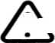
* ^ Take the mobile control unit to work position С
9) Position the locking ring on the rim with the help of the disk as shoen
in Fig. Y.
Move the tool carrier arm to its non-working position and close the spindle arms completely. Support the wheel so that it does not fall off the
spindle.
DANGER!

This operation can be extremely dangerous.
Do it manually only if you are certain you can keep the wheel
balanced.
For large and heavy tyres an adequate lifting device must be used.
10)Move the platform to free the wheel from the spindle.
11)Remove the wheel.
DANGER!

This operation can be extremely dangerous.
Do it manually only if you are certain you can keep the wheel
balanced.
For large and heavy tyres an adequate lifting device must be used.
13 ORDINARY MAINTENANCE
WARNING

Each maintenance operation must be effected only after the disconnection of the plug from electric network.
To ensure that this U-290 tyre changer works perfectly over years, carry out the routine maintenance schedule described below:
1) lubricate the following parts from tiom time to time, after a thorough
cleaning with naphtha:
-the various swivels on the spindle -the tool bracket slide plate -the carriage guide plate.
2) Grease the spindle bracket lift cylinder from time to time and also
its swivel. Add the grease through the grease through the grease.
25

NB: To reach the grease nipple on the bracket, remove the plastic cap by-removing the two self-tapping screws as shown in Fig. J.
3) From time to time check the oil level in the hydraulic power pack. Use
the dipstick under the reservoir cap.
If necessary top up with Esso Nuto H46 or similar hydraulic oil(eg, Agip Oso 46, BP Energol HLP).
4) From time to time check the oil level in the gear unit which, when the
tool carrier bracket is completely lowered at end travel, should not
show the sight glass on the gear casing as completely empty. If
necessary top up with Esso Spartan EP 320 or similar oil(eg, Agip Fl
REP 237, BP GRX P 320, Chevron Gear compound 320, Mobil Gear 632, sell
omala oil 320, Castrol Alpha SP 320).
NB: If the oil in the gear unit or the hydraulic power pack has to be changed, note that the gear unit casing and the power pack reservoir have specific drain plugs.
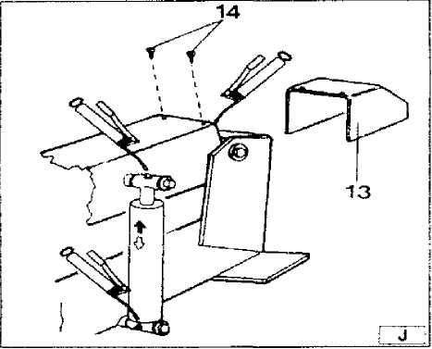

WARNING
Each maintenance operation must be effected only after the disconnection of the plug from electric network.

14 TROUBLE
J.J1U

After having switched the general button on the electric pack, the general warning light does not light on and no control can function.
- The feeding plug is not connected.
- There is no current in the electric mains.
- Insert plug in the socket.
- Restore the electric mains.
After having switched the general button on the general warning light also switches on but the motor on the hydraulic power pack does not function.
1) The magneto-thermic switch for motor protection is working.
1) Call for technical aid to see what is the problem and restore the machine.

WARNING

If, in spite of the above mentioned indications the tyre changer does not work properly, do not use it and call for technical assistance
26

15 PNEUMATIC DRAWING
The U-290tyre changer has got a fork(1, Fig. A) which has been position there on purpose for moving the machine. Follow these instructions:
- Low the turntable holding arm(2, Fig. A) completely down.
- Close completely the jaws of the chuck(3, Fig. A).
- Bring the sliding table (4, Fig. A) at the end of its travel, near the arm.
- Insert into the lifting fork a hoisting belt(at least 60mm wide and
of a length sufficient to bring the hook of the belt above the tyre
changer).
- With the special belt ring bring the 2 ends of the belt together and
lift with a sufficiently strong lifting truck.
16 STORING
If the machine as to be stored for a long time 3-4 months you have to:
- Close the jaws of the chuck; low the chuck holding arm down; low the
tool holding arm down, in working position.
- Disconnect the machine form all power sources.
- Grease all the parts that could be damaged if they dry out:

- the chuck
- the slot of the tool holding arm
- the slides of the carriage
- the tool
Empty oil/hydraulic fluid reservoirs and wrap the machine in a sheet of
protective plastic to prevent dust from reaching the internal working
parts.
If the machine as to working again after a long storing period, it is
necessary to;
- put the oil into the reservoirs again.
- With a turn screw press the pin on the middle of the electro-valves
of the hydraulic power pack (see Fig. X) in order to manually unlock the
electro-valves which could be locked after a long period of inactivity.
- Restore the electric connection.
17 SCRAPPING A MACHINE
When you machine' s working life is over and it can no longer be used, it must be made inoperative by removing any connection to power sources. These units are considered as special waste material, it should be broken down into uniform parts and disposed of in compliance with current laws and regulations.
If the packing are not polluting or non-biodegradable, deliver them to appropriate handling station.
27

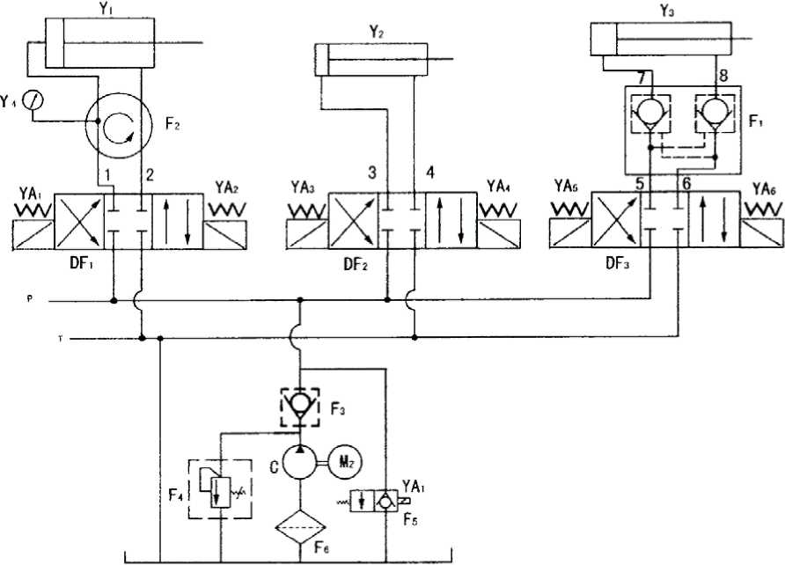
18 PNEUMATIC DRAWING

UNMBER | NAME | MODEL | QUANTITY
Y1 | THICX HYDRAULIC CYLINDER | TGφ 95×200 | 1
Y2 | LCNG HYDRAULIC CYLINDER | TGφ 50×1000 | 1
Y3 | SHCRT HYDRAULIC CYLINDER | TGφ 50×380 | 1
Y4 | FRESSING METER | Y-40 | 1
U 2 | ASSEMBLY OF SQUARE BEND SND PIPE | GPU φ 6-1-4UMPa1200 | 2
3, 5^ 6 | STRAIGHTWAY FOUND PIPE JOINT | GPU φ6-1-4UMPa880 | 3
4 | STRAIGHTWAY FOUND PIPE JOINT | GPU φ6-1-4UMPa1520 | 1
7 | HYDRAULIC CYLINDER TIE-IN | TGφ8×140 | 1
8 | HYDRAULIC CYLINDER TIE-IN | TGφ8×105 | 1
M2 | MOTOR | Y-90L4 | 1
F1 | HYDRAULIC LOCK | TGF-YS6 | 1
F2 | ROTARY PIPE JOINT | TGF-HJ4 | 1
F3 | CHECK VALVE | TGF-DC6C | 1
F4 | RELIEF VALVE | TGF-YL4-C | 1
F5 | NORMAL OPEN SOLENOID VALVE | TGF-DF24 | 1
F6 | HYDRAULIC FILTER | TGL-M18 | 1
DF1—DF3 | HYDRAULIC SOLENOID VALVE | 4WE6E61/CG24 | 3
С | GEAR PUMP FEED OIL CIRCUIT | CBK-2. 5 | 1
P | FEED OIL CIRCUIT
T | BACK OIL CIRCUIT
28
19 ELECTRIC DRAWINGS
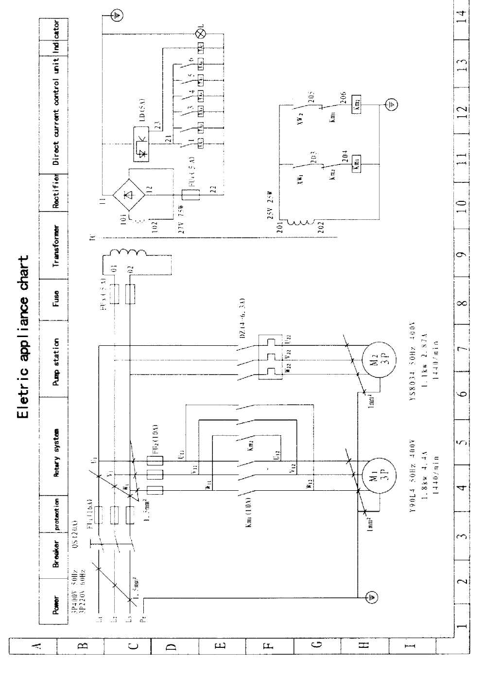
29
20 EXPLODED DRAWINGS
FIG. 1 GRUNDRAHMEN-BASEFRAME-CADRE DE BASE
30
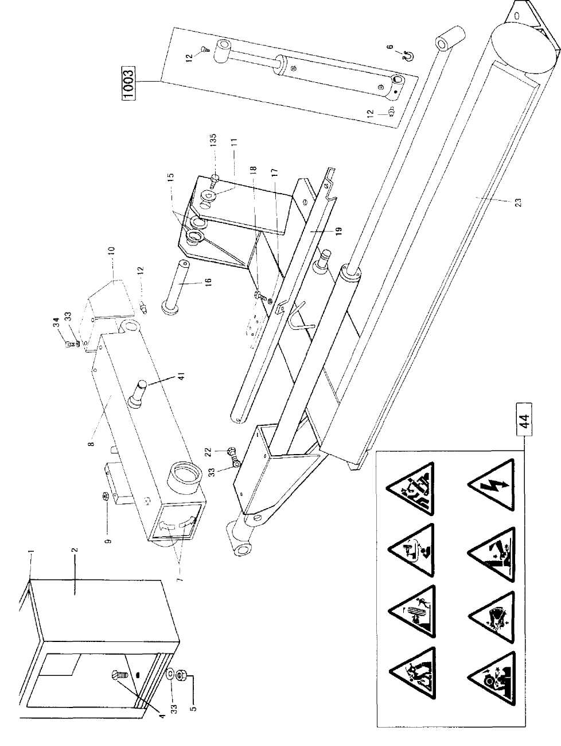
FIG 2 HUBZYUNDER+SCHLITTENZYLINDER
LIFTING CYLINDER (SHORT)+CARRI AGE CYLINDER (LONG) VERIN DE LEVAGE+VERIN CHARIOT
31
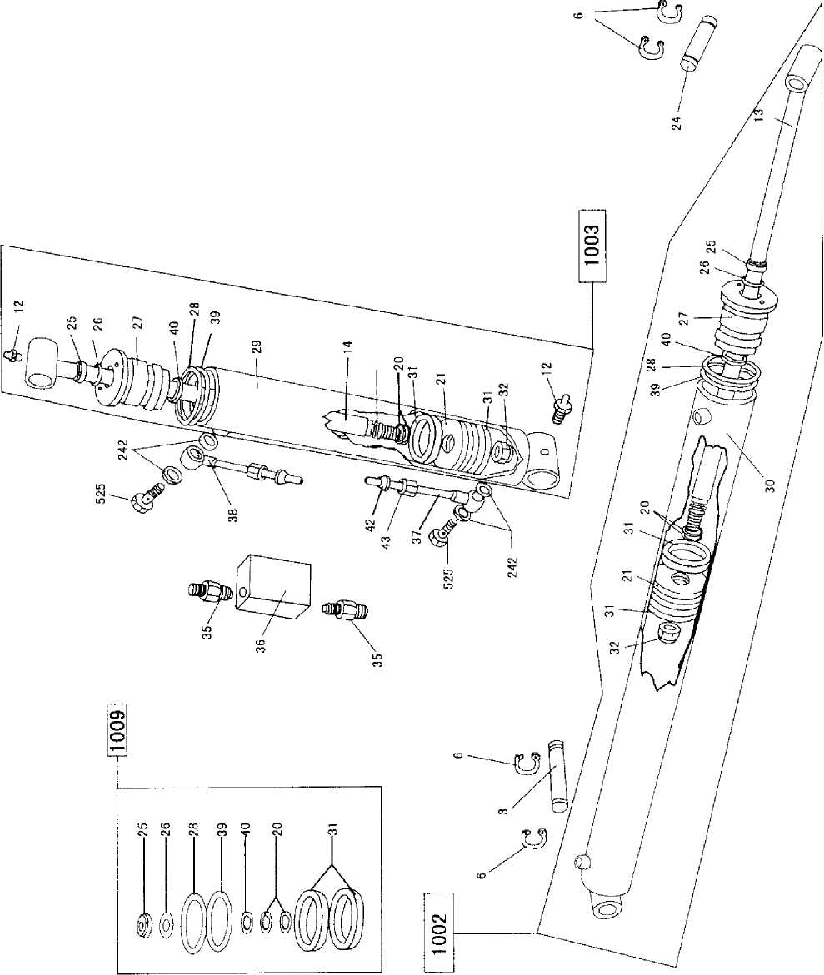
F I G. 3 SCHL i TTEN-CARRI AGE-CHAR IOT
32
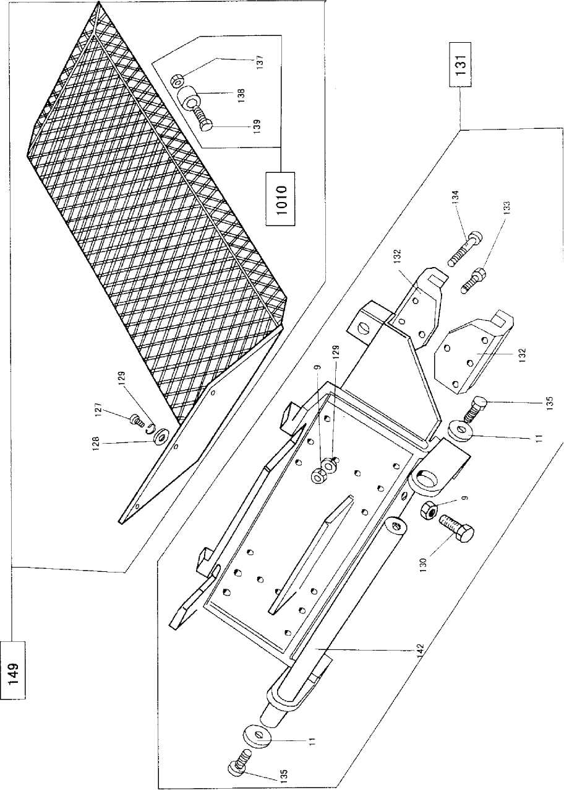
FIG. 4 WERKZEUGAUFNAHMEARM-MOUNTING ARMBRAS DE MONTAGE
33
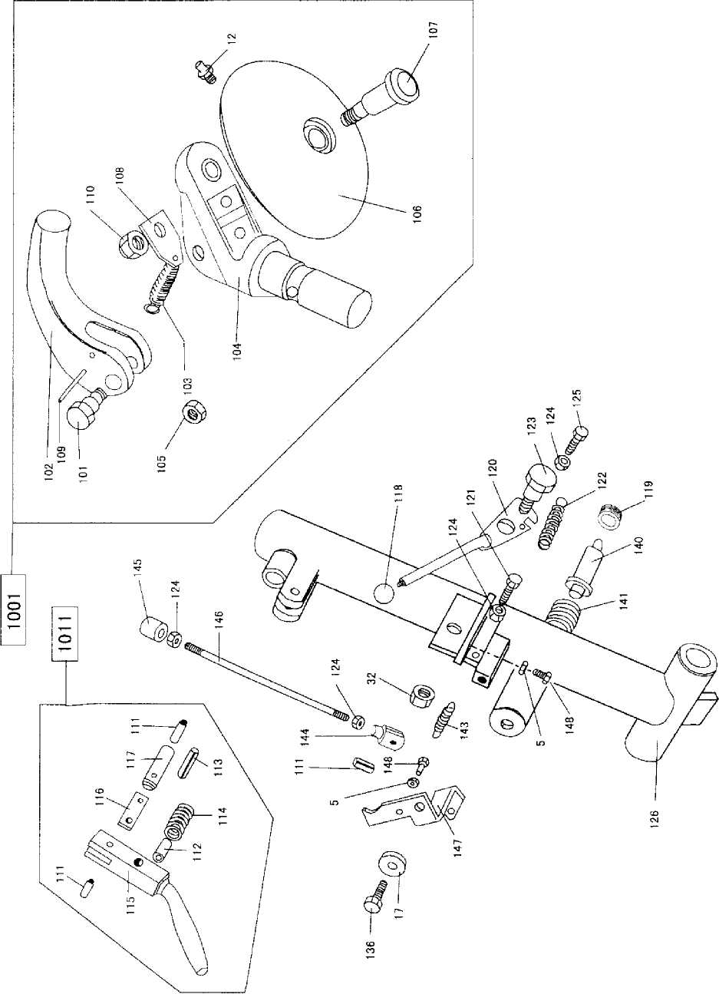

FIG.5
SPANNANTRIEB-CHUCK DRIVE UN I TENS D^ENTRAIMEMENT DU MANDRIN

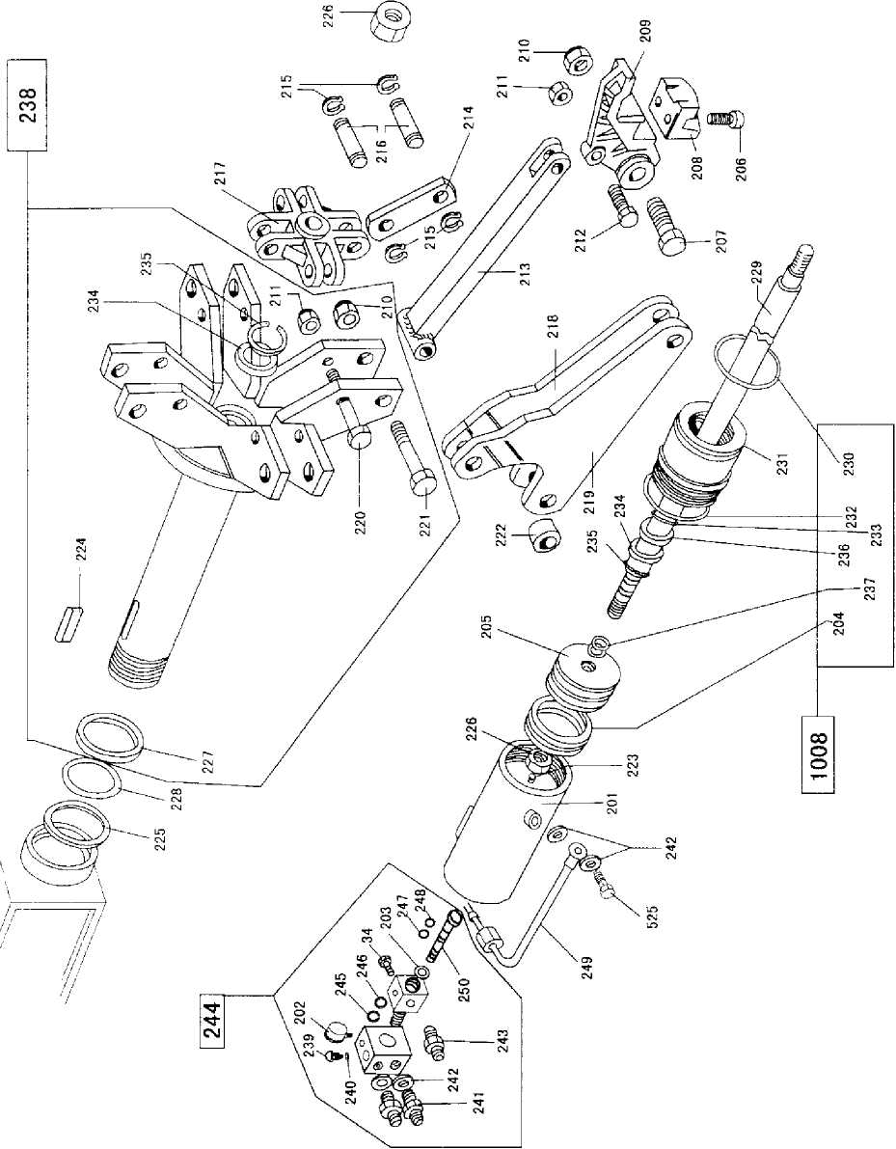
34

F I G. 6 GETRIEBE-GEARBOX-REDUCTEUR
35
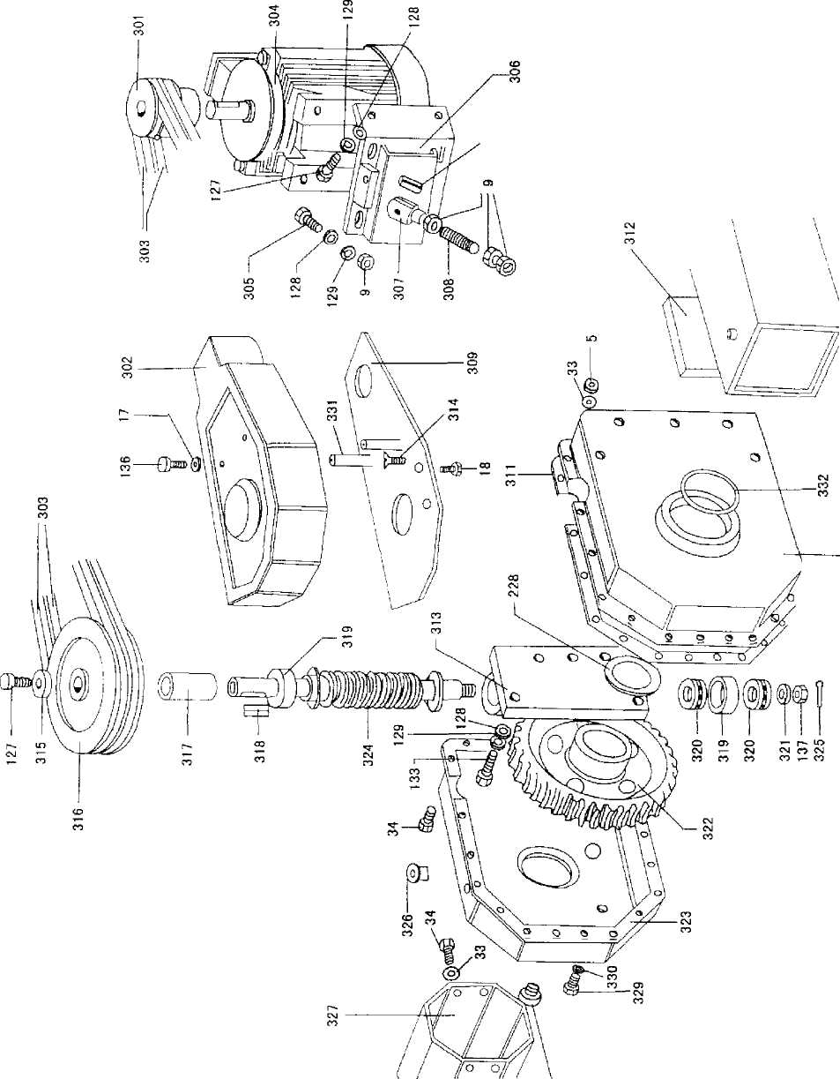
F I G. 7 HYDRAUKIKAGGREGAT-HYDRAULIС UN IT-UNlТЕ HYDRAULIQUE
36
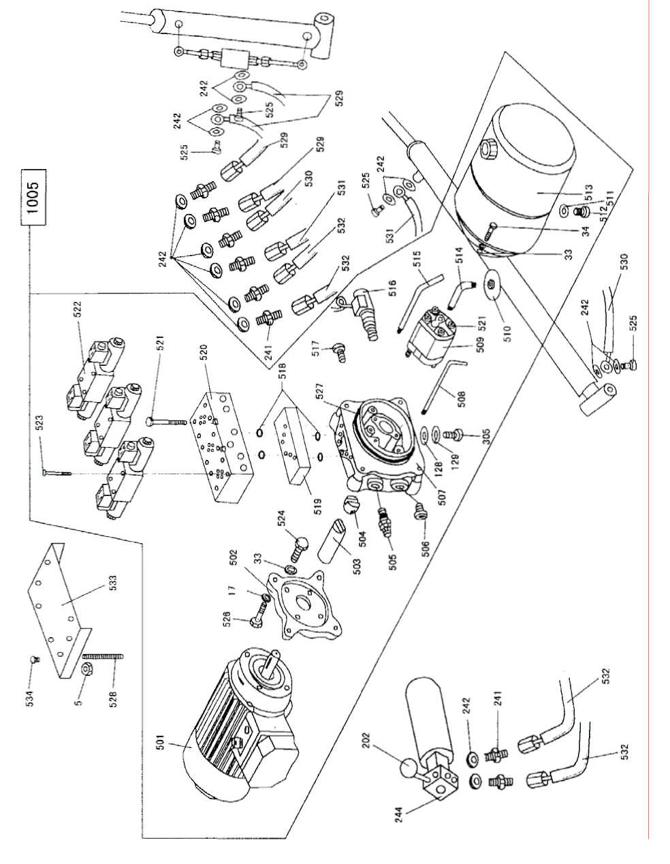
F I G. 8 ZUBEHOR-ACCESSORIES-ACCESSOI RES
37
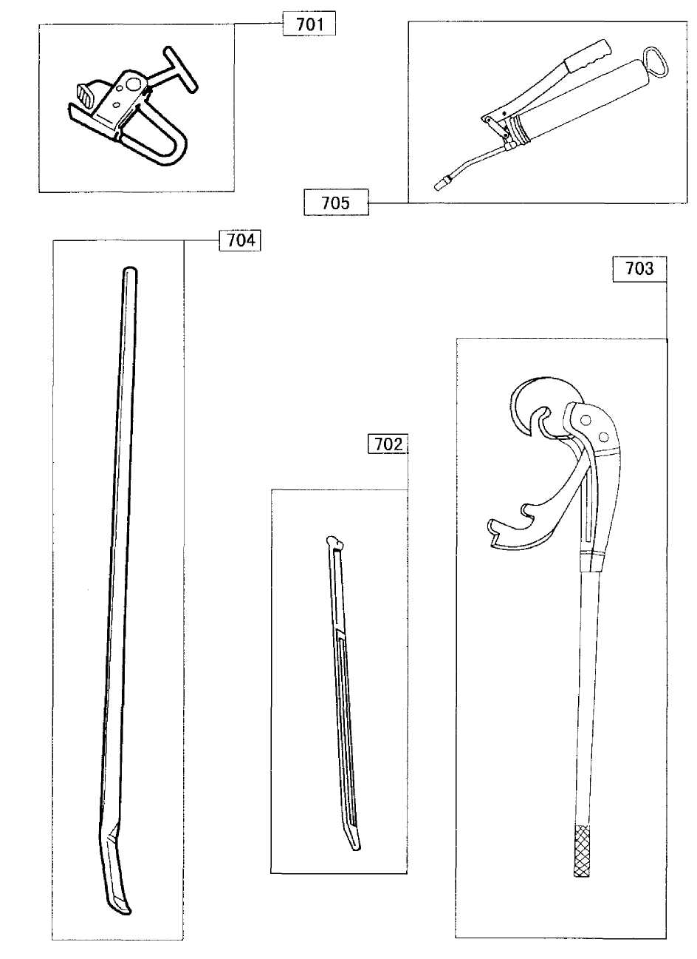
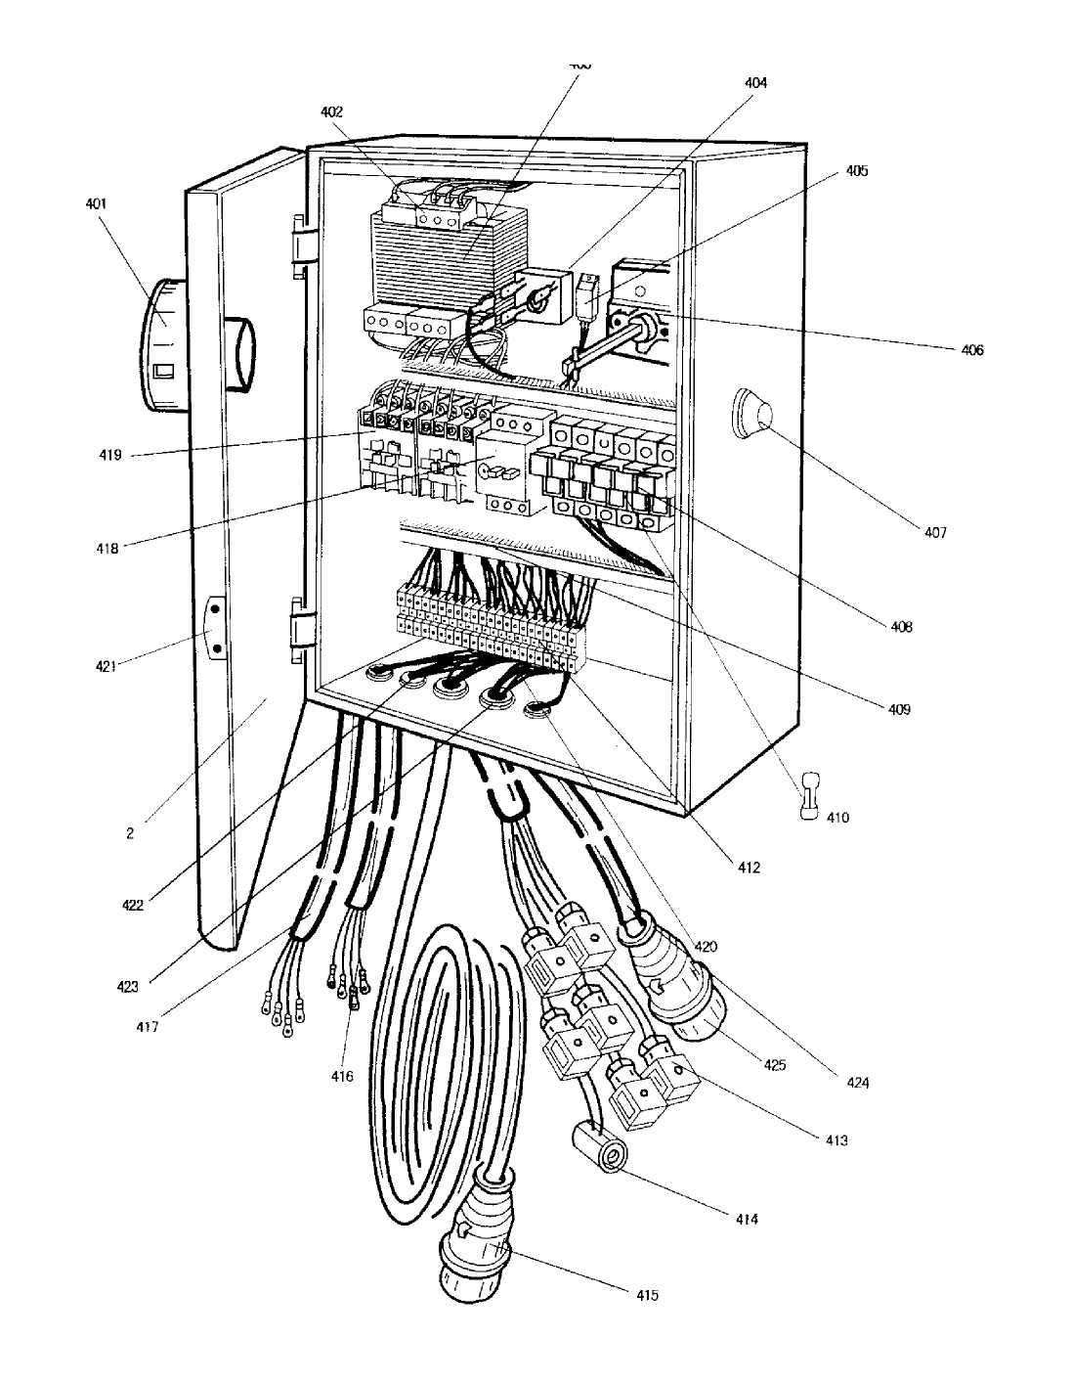
38
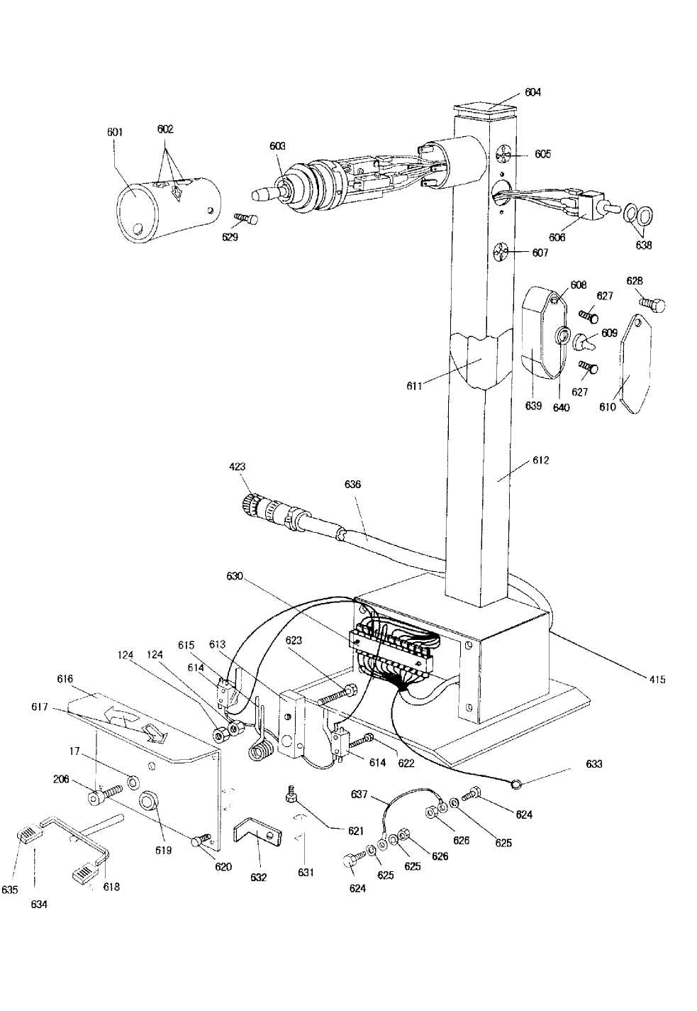
39
21 Список запчастей

No. | Описание
1 | Крышка электрокоробки
2 | Электрокоробка
3 | Длинная фиксирующая ось для длинного цилиндра
4 | Винт M6x20
5 | Муфта M6
6 | Стопорное кольцо нар. диаметр 24
7 | Наклейка-указатель
8 | Рука зажимного патрона
9 | Муфта M10
10 | Крышка каркаса
11 | Шайба Φ 5x16x1.5
12 | Olier
13 | Удлиненный шток цилиндра
14 | Укороченный шток цилиндра
15 | Шайба
16 | Вал прижимного патрона
17 | Шайба Φ8
18 | Винт M8x12
40
19 | Крышка удлиненного цилиндра
20 | Уплотнительное кольцо Φ 20x2.4
21 | Поршень
22 | Винт M6x10
23 | Frame
24 | Короткая фиксирующая для длинного цилиндра
25 | Пылезащитное уплотнение
26 | Уплотнительное кольцо Φ 25x2.65
27 | Круглая гайка
28 | Уплотнительное кольцо Φ 60x3.1
29 | Обшивка укороченного цилиндра
30 | Обшивка удлиненного цилиндра
31 | Прокладка для вала YD50
32 | Самостопорящаяся гайка M14
33 | Шайба
34 | Винт M6x1 6(70)
35 | Наконечник M19-M14
36 | Обратный клапан
37 | Шланг Φ 8x110
38 | Соединение
39 | Уплотнительное кольцо Φ 41.5x3.55
41
40 | Прокладка для вала YD32
41 | Ось для вала укороченного цилиндра
42 | Винтовая стяжка Φ8
43 | Проставка M14x1.5
44 | Набор предупредительных этикеток
101 | Ось
102 | Монтажный инструмент
103 | Пружина Φ18
104 | Инструментодержатель
105 | Гайка низких оборотов M1 6x1.5
106 | Отжимной диск
107 | Отжимная ось
108 | Крюк
109 | Расятяжимая ось Φ8x60
110 | Самостопорящаяся гайка M20x1.5
111 | Расятяжимая ось Φ6x20
112 | Расятяжимая ось Φ 10x20
113 | Расятяжимая ось Φ8x30
114 | Возвратная пружина
115 | Рычаг кулачка
42
116 | Фитинг кулачка
117 | Кулачок
118 | Рукоятка
119 | Винт M46x1.5
120 | Трещетка
121 | Винт M8x45
122 | Пружина
123 | Эксцентриковый болт трещетки
124 | Гайка M8
125 | Винт M8x25
126 | Монтажная рука
127 | Винт M10x20
128 | Шайба Φ10,5
129 | Шайба Φ8
130 | Винт М10х30
131 | Каретка
132 | Направляющая каретки
133 | Винт M10x30(70)
134 | Винт M10x70(70)
135 | Винт M12x2
136 | Винт M8x20
43
137 | Гайка M16
138 | Ролик
139 | Винт M16x90
140 | Выталкиватель руки
141 | Нажимная пружина для установки рычага
142 | Направляющий вал для установки рычага
143 | Пружина
144 | Вилка рычага со стержнем
145 | Кулачок
146 | Вал
147 | Опока
148 | Винт M6x25
149 | Carriage with roller
201 | Корпус цилиндра Φ 95
202 | Манометр
203 | Уплотнительное кольцо Φ32x3.5
204 | Манжета DAS 9575
205 | Поршень
206 | Винт M8x25(70)
207 | Винт M18x1.5
44
208 | Зажим
209 | Держатель зажима
210 | Самоконтрящаяся гайка M18
211 | Самоконтрящаяся гайка M12
212 | Специальный винт M12
213 | Арматурный стержень
214 | Соединительная штанга для зажимного патрона
215 | Наружное стопорное кольцо Φ16
216 | Ось для соединительной кулисы
217 | Узел зажимного патрона
218 | Правый рукав
219 | Левый рукав
220 | Специальный удлиненный винт M12
221 | Специальный удлиненный винт M18x1.5
222 | Втулка руки
223 | Винт M6x10(up)
224 | Ключ 60x20x12
225 | Уплотнительное кольцо 619
226 | Муфта M24x2
227 | Защитное кольцо
228 | Шайба Φ75x91x0.5
45
229 | Приводной вал зажимного патрона
230 | Уплотнительное кольцо Φ 90x5.7
231 | Передний фланец для цилиндра Φ 95
232 | Уплотнительное кольцо Φ 87.5x3.55
235 | Внутреннее стопорное кольцо int. Φ50
236 | Прокладка YD35
237 | Уплотнительное кольцо Φ 24x2.4
238 | Зажимной патрон в сборе
239 | Односторонний клапан(сохряняет давление)
240 | Набор шайб JB982-77
241 | Наконечник M14-M14(выгнутый)
242 | Медная шайба Φ14.5
243 | Наконечник M14-M14(вогнутый)
244 | Поворотный патрубок в сборе
245 | Уплотнительное кольцо Φ 31.5x2.65
246 | Шайба Φ 35.9x31.5x1.5
247 | Шайба Φ 8x11x1.5
248 | Уплотнительное кольцо Φ 12x1.9
249 | Медная трубка Φ 12x1.9
250 | Тяга поворотного распределителя
46
301 | Шкив
302 | Крышка для v-образного ремня
303 | Ремень 3V-335
304 | Гидромотор 220/380V, 50hz
305 | Винт M10x25
306 | Опора гидромотора
307 | Выступ скобы с осью
308 | Анкерный болт
309 | Опора крышки
310 | Задняя крышка редуктора
311 | Прокладка для редуктора
312 | Прокладка для стыковой накладки
313 | Опора червяка
314 | Винт М10хЗ0
315 | Специальная шайба
316 | Шкив ведущего ремня
317 | Винтовое зацепление
318 | Ключ 8x7
319 | Радиальный подшипник
320 | Упорный подпятника
321 | Шайба Φ 38x16.2x5
47
322 | Винтовое зубчатое колесо
323 | Передняя крышка редуктора
324 | Ходовой винт
325 | Шпилька
326 | Клин для механизма
327 | Кожух цилиндра зажимного патрона
328 | Масломерное стекло
329 | Заглушка кожуха редуктора
330 | Уплотнительное кольцо для заглушки редуктора
331 | Защитный кожух вала
332 | Уплотнительное кольцо Φ105x3.7
401 | Главный выключатель (500V,20A)
402 | Гнездо предохранителя
403 | Трансформатор в сборе (100VA,400V)
404 | Мостиковый выпрямитель
405 | Arrange
406 | Предохранительный выключатель
407 | Сигнальная лампа (DC24V)
408 | Корпус предохранителя(350V-500V)
409 | Arrange for the line
48
410 | Предохранитель (32A,10A)
411 | Arrange for socket
412 | Гнездо для соленоида
413 | Обмотка переключателя DC24V
414 | Главный штепсель
415 | Кабель к штепселю панели управления
416 | Кабель к мотору зажимного патрона
417 | Кабель к мотору гидравлической станции
418 | Предохранительный выключатель
419 | Контактор
420 | Свинцовый кабель
421 | Рукоятка
422 | Линия энергоснабжения
423 | Штепсель линии энергоснабжения
523 | Винт M5x35(70)
524 | Винт M6x20(70)
525 | Специальный наконечник
526 | Винт M8x25(70)
527 | Уплотнительное кольцо Φ105x3.5
528 | Винт M6
49
529 | Короткий шланг для цилиндра
530 | Короткий шланг для удлиненного цилиндра
531 | Длинный шланг для удлиненного цилиндра
532 | Толстый шланг для цилиндра
533 | Крышка соленоида
534 | Trunk-nail M6
601 | Крышка переключателя
602 | Наклейка
603 | Сильфон
604 | Кожух панели управления
605 | Наклейка
606 | Переключатель полярности
607 | Наклейка
608 | Кронштейн переключателя
609
610 | Крышка переключателя
611 | Жгут кабелей для панель управления
612 | Панель управления
613 | Микроручка управления
614 | Микровыключатель
50
615 | Усатая пружина
616 | Крышка для рычага педали
617 | Наклейка
618 | Рычаг педали
619 | Соединительная втулка для штепсельной розетки
620 | Винт M5x20(70)
621 | Винт M6x10(70)
622 | Винт M4x30(закругленный)
623 | Винт M4x10(закругленный)
624 | Винт M5x10(закругленный)
625 | Прокладка для консоли управления
626 | Гайка
627 | Патрон педали
628 | Патрон заземления
629 | Рычаг педали в сборе
701 | Зажим для литых дисков
702 | Рычаг для шины
703 | Длинный рычаг для шины
704 | Направляющий рычаг для борта шины
705 | Масляная помпа
51
1001 | Монтажная головка в сборе
1002 | Длинный цилиндр в сборе
1003 | Короткий цилиндр в сборе
1005 | Насосная станция в сборе
1008 | Набор манжет YD d95 для цилиндра
1009 | Набор манжет YD d50 для цилиндра
1010 | Вращающий цилиндр с винтом и гайкой
1011 | Кулачок в сборе для монтажного инструмента
52

